Report for: | Health and Wellbeing Board
Date of Meeting: | 22nd June 2023
Subject: | Health and Wellbeing Strategy – Healthy Policy & Practice
Responsible Officer: | Carole Furlong, Director of Public Health
Public: | Yes
Wards affected: | All wards
Enclosures: | Harrow Health and Wellbeing Strategy

Section 1 – Summary and Recommendations
The ‘Healthy Policy & Practice’ domain within the strategy has three key areas of focus:
- Making every contact count everyone’s business
- Community involvement and engagement
- Creating and embedding Health in All Policies

To support developing a partnership and system-wide delivery plan, the Health and Wellbeing Board is asked to consider the following for each of the ‘Healthy Policy & Practice’ work programme areas:
  - What are the strengths and opportunities for the work programme?
  - What are the challenges, threats and risks for the work programme?
  - What will partners commit to delivering?
  - How will success be measured?

Section 2
Background
Harrow’s Health and Wellbeing Strategy was endorsed at the Health and Wellbeing Board in November 2022. The strategy set out plans to report on each of the domains, Healthy People, Healthy Policy & Practice and Healthy Place, once a year.

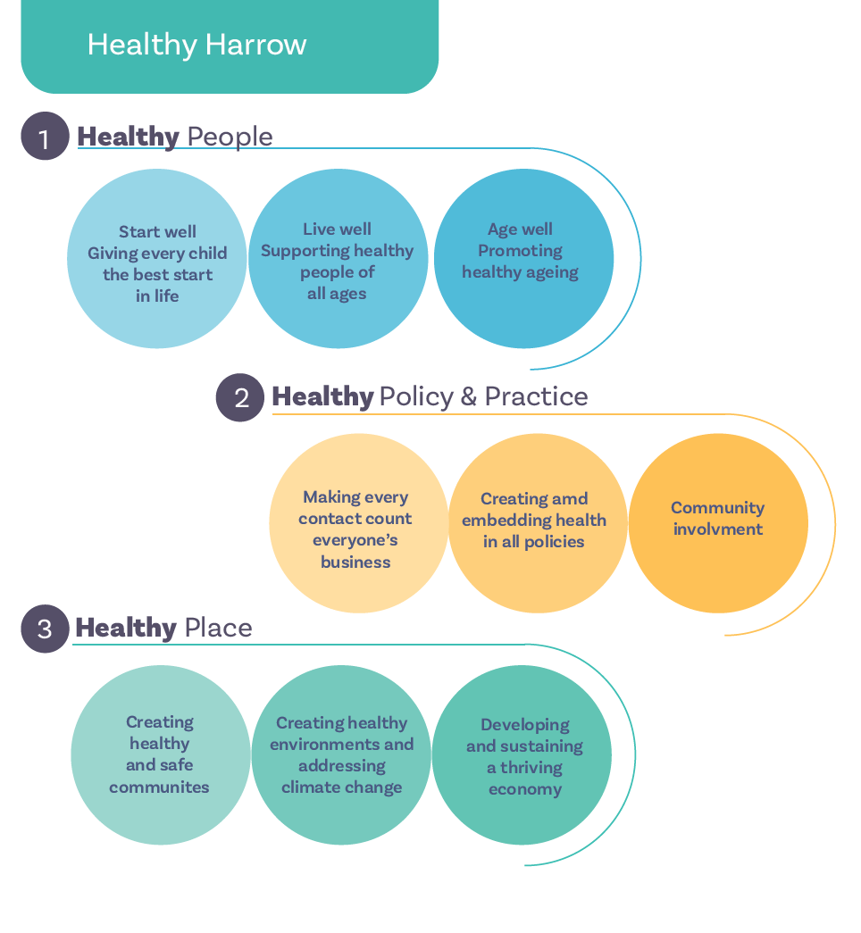This quarter, the board is asked to consider the ‘Healthy Policy & Practice’ domain. In particular, focussing on the three key work programme areas of the domain and the commitments made within the strategy:

Making every contact count (MECC) everyone’s business

MECC enables the opportunistic delivery of consistent and concise healthy lifestyle information and enables individuals to engage in conversations about their health at scale across organisations and populations. The point about MECC interventions is that they don’t need to be undertaken by a health professional. By developing some simple key communication skills and communicating evidence based healthy lifestyle messages – everyone can have a role to play. MECC is about utilising those everyday conversations with the public to make a difference. Commitments within the strategy include:

- Identifying which communities and neighbourhoods within Harrow that would benefit from the MECC programme through a population health management approach
- Working with the community and voluntary sector to embed the MECC approach
- Developing MECC training for the Harrow workforce, as well as community groups

Community involvement and engagement

Community involvement and engagement is more than consultation.
Involvement and engagement is to systematically highlight the known issues to the communities that they matter to the most, to explore motivations and barriers and to create ownership and enable residents to take some control in their health and wellbeing choices. Health, care, community & voluntary sector partners will need to initially coordinate this activity, based on the priorities arising from the JSNA and to initially propose which issues are most appropriate to approach the community with. Commitments within the strategy include:

- Produce a systematic basis for engagement topics and corresponding schedule of involvement and engagement themes with the community
- Identify who are broad and specific stakeholder groups are and ensure an appropriate level of engagement
- Access to venues and resources (e.g. Children’s Centres, Family Hubs, Drop-In Cafes)
- Encouraging volunteering - including micro-volunteering, working as and with local employers
- Joining up support in the community (e.g. around CAB and debt support)
- Prioritising and investing long-term in what we have (JOY social prescribing platform and other digital transformation)

Creating and embedding Health in All Policies

The Health and Wellbeing Strategy outlines a wide range of determinants
(building blocks) of health and wellbeing including education, housing,
transportation and economic productivity. Each of these building blocks of
health will have separate policies directing their activity, and as such, it is
important that these policies all demonstrate an understanding on how they
can positively impact health and wellbeing. This concept is referred to as
Health In All Policies (HIAP).

The Health and Wellbeing Strategy crosses many organisational boundaries.
Each Health and Wellbeing member organisation will ensure that the strategy,
aims, and principles are reflected in their own Corporate Objectives. Commitments within the strategy include:

- Embed a health in all policies approach throughout the system
- Supporting staff to understand how they can influence health and wellbeing through their policies
- Agree and standardise the approach to Health Impact assessments throughout the borough
- Support the delivery of Core20PLUS5 programme through primary care
- Embed Population Health Management as an approach across the system.

For the board to consider and discuss:
To support developing a partnership and system-wide delivery plan, for each of the key programme areas, the board is asked to consider and discuss:

- What are the strengths and opportunities for the work programme?
- What are the challenges, threats and risks for the work programme?
- What will partners commit to delivering?
- How will success be measured?

Financial Implications/Comments
There are no direct costs associated with delivering the health and wellbeing strategy.
Whilst there are no additional direct financial implications arising from this report, the prioritisation of strategy, through the borough-based partnership and wider system, will need to be contained within existing partner resources, which includes the annual public health grant.

Legal Implications/Comments
Section 116A of the Local Government and Public Involvement in Health Act 2007, stipulates that it is the responsibility of the local authority and integrated care boards to prepare a local health and wellbeing strategy.

The Health and Social Care Act 2012 provides responsibility to the Health and Wellbeing Board for the oversight of the local health and wellbeing strategy.

A key responsibility of the Health and Wellbeing Board is to therefore have oversight and accountability of the proposed strategy.

Risk Management Implications
The health and wellbeing strategy does not present any risks, or suggest any mitigation

Risks included on corporate or directorate risk register? No

Separate risk register in place? No

The relevant risks contained in the register are attached/summarised below. n/a

Equalities implications / Public Sector Equality Duty
Was an Equality Impact Assessment carried out? No

Section 3 - Statutory Officer Clearance (Council and Joint Reports)
Statutory Officer: Donna Edwards
Signed on behalf ofthe Chief Financial Officer
Date: 02/06/23
Statutory Officer: Sharon Clarke
Signed on behalf of the Monitoring Officer
Date: 06/06/23
Chief Officer: Senel Arkut
Signed by the Corporate Director
Date: 09/06/23

Mandatory Checks

Ward Councillors notified: NO, as it impacts on all Wards

Section 4 - Contact Details and Background Papers
Contact: Seb Baugh, Consultant in Public Health, sebastien.baugh@harrow.gov.uk
Background Papers: Harrow Health and Wellbeing Strategy
If appropriate, does the report include the following considerations?
1. Consultation NO
2. Priorities NO

